**MODULE: 5 (Database)**

**SQL Queries**

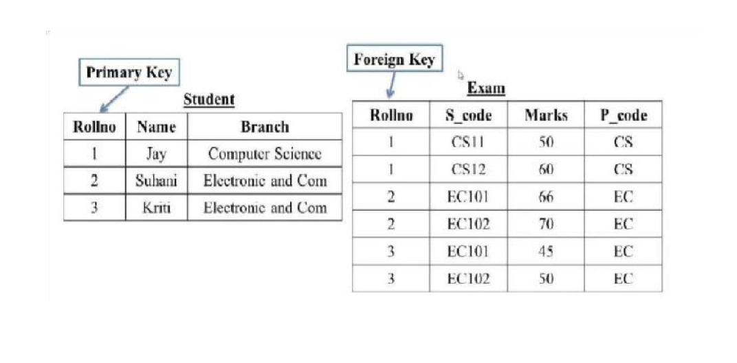**Question 1:** Create Table Name: Student and Exam

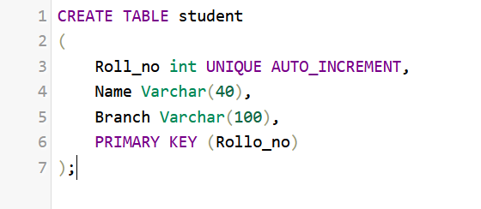**Answer: Student Table Query**

**Exam Table Query**

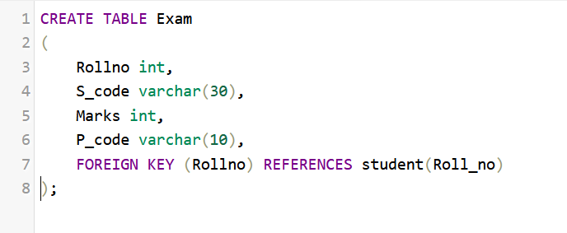

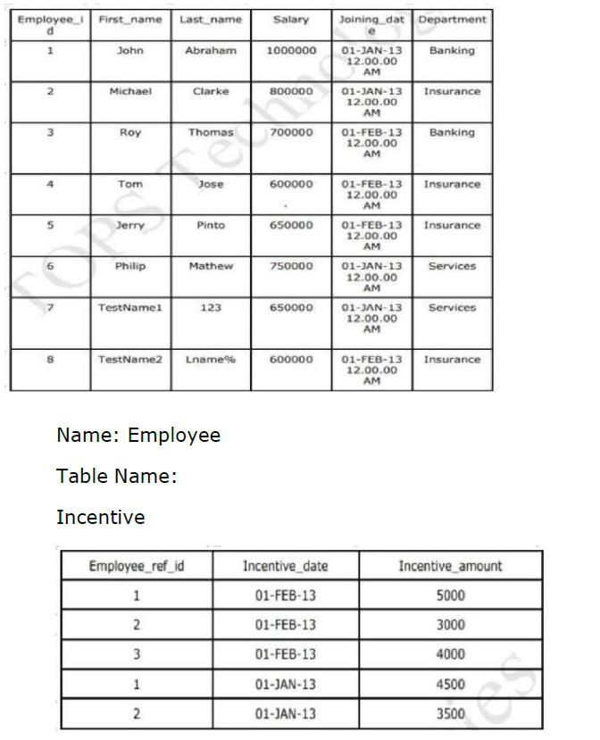**Question 2:** Create table given below: Employee and IncentiveTable.

**Answer:**

**Employee Table Query**

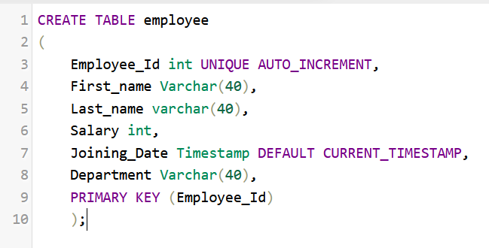

**Incentive Table Query**

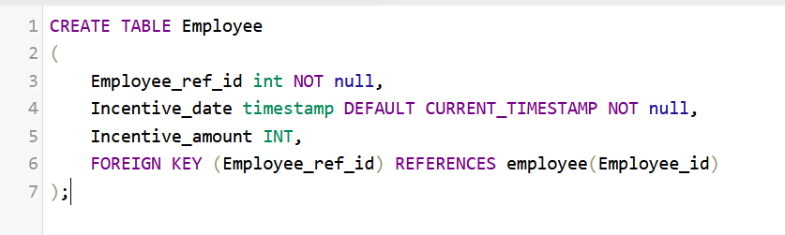

**Question 3:** Get First_Name from employee table using Tom name “Employee Name”.

**Answer:**

SELECT first_name FROM employee ORDER BY first_name ASC, salary DESC;

**Question 4:** Get FIRST_NAME, Joining Date, and Salary from employee table.

**Answer:**

SELECT first_name, joining_date, salary FROM employee;

**Question 5:** Get all employee details from the employee table order by First_Name ascending and Salary descending?

**Answer:**

SELECT * FROM employee ORDER BY first_name ASC, salary DESC;

**Question 6:** Get employee details from employee table whose first name contains ‘J’.

**Answer:**

SELECT * FROM employee WHERE first_name LIKE 'J%';

**Question 7, 8:** Get department wise maximum salary from employee table order by salaryascending?

**Answer:**

SELECT department, MAX(salary) AS max_salary FROM employee

GROUP BY department ORDER BY max_salary ASC;

**Question 9:**  Select first_name, incentive amount from employee and incentives table forthose employees who have incentives and incentive amount greater than 3000

**Answer:**

**Question 10:**  Create After Insert trigger on Employee table which insert records in viewtable

**Answer:**

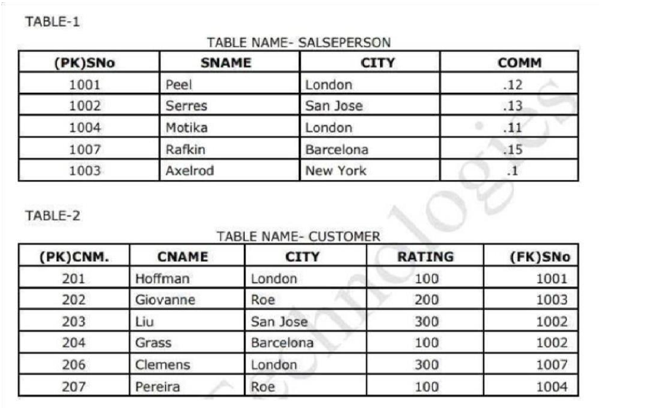**Question 11:**  Create table given below: Salesperson and Customer

**Answer:**

**Salesperson Table Query:**

**Customer Table Query:**

**Question 12, 13:**  Retrieve the below data from above table. All orders for more than $1000.

**Answer:**



**Question 14:** Names and cities of all salespeople in London with commission above 0.12.

**Answer:**

**Question 15:** All salespeople either in Barcelona or in London.

**  
Answer:**

**Question 16:**  All salespeople with commission between 0.10 and 0.12. (Boundary

valuesshould be excluded).

**Answer:**

“SELECT * FROM salesperson WHERE comm > 0.10 AND comm < 0.12;”

**Question 17:**  All customers excluding those with rating <= 100 unless they are located in Rome

**Answer:**



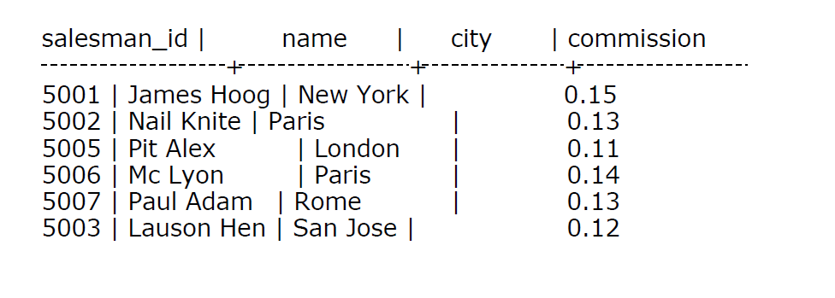**Question 18:**  Write a SQL statement that displays all the information about all salespeople

**Answer:**

“SELECT * FROM salespeople;”

**Question 19:**  From the following table, write a SQL query to find orders that are delivered by a salesperson with ID. 5001. Return ord_no, ord_date, purch_amt.

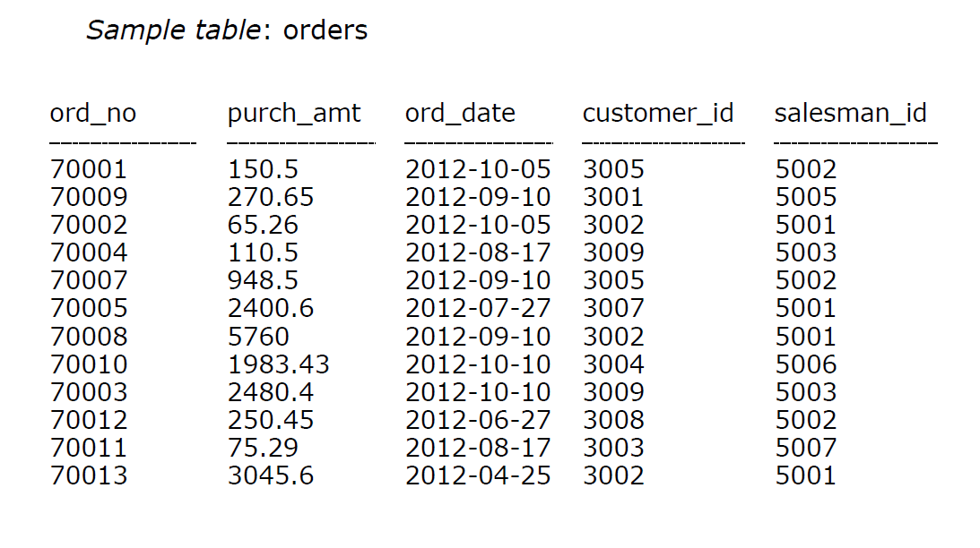

**Answer:**

**Question 20:**  From the following table, write a SQL query to select a range of products whose price is in the range Rs.200 to Rs.600. Begin and end values are included. Return pro_id, pro_name, pro_price, and pro_com.

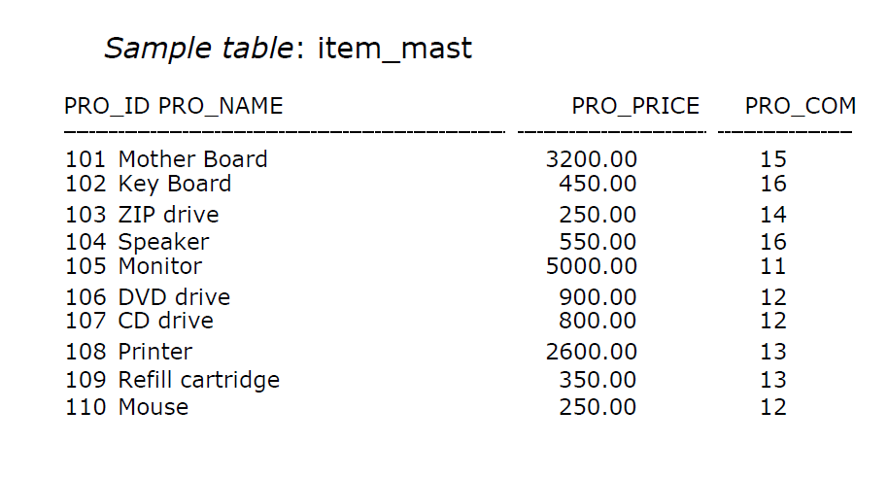

**Answer:**

**Question 21:**  From the following table, write a SQL query to calculate the average price for a manufacturer code of 16. Return avg.

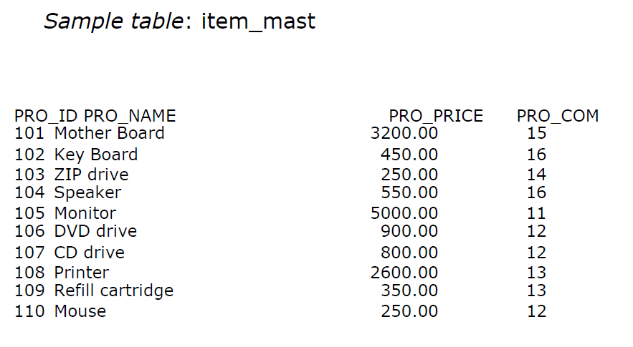

**Answer:**

**Question 22:**   From the following table, write a SQL query to display the pro_name as 'Item Name' and pro_priceas 'Price in Rs.'

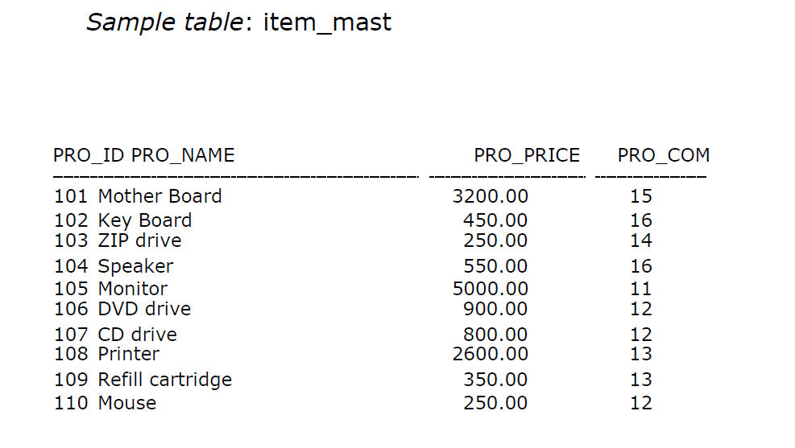

**Answer:**



**Question 23:** From the following table, write a SQL query to find the items whose prices are higher than or equal to $250. Order the result by product price in descending, then product name in ascending. Return pro_name and pro_price.

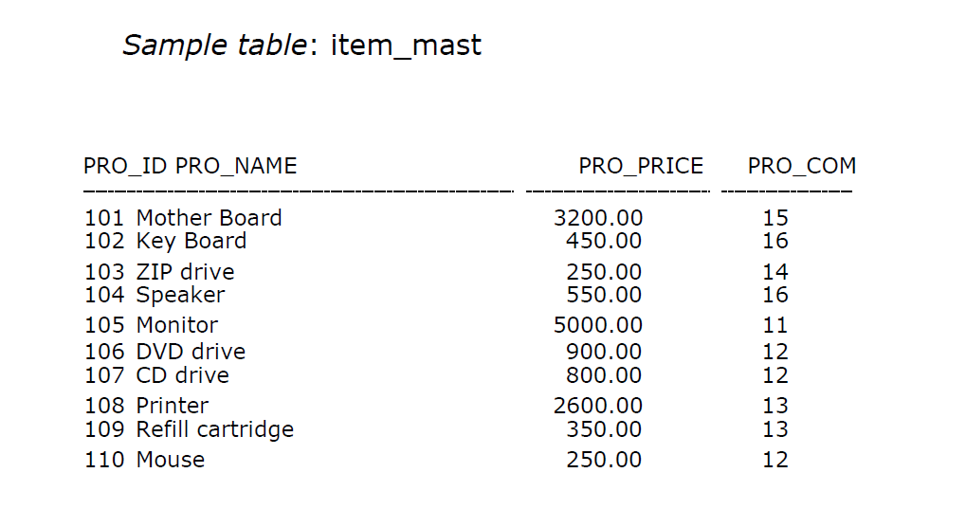

**Answer:**



**Question 24:** From the following table, write a SQL query to calculate average price of the items for each company. Return average price and company code.

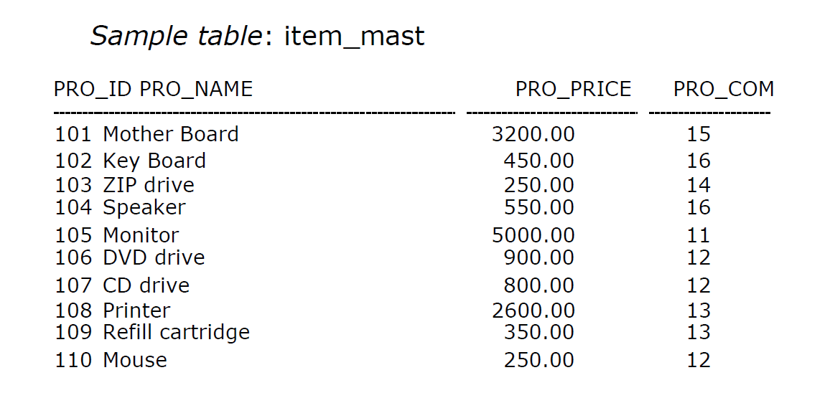

**Answer:**

